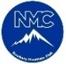
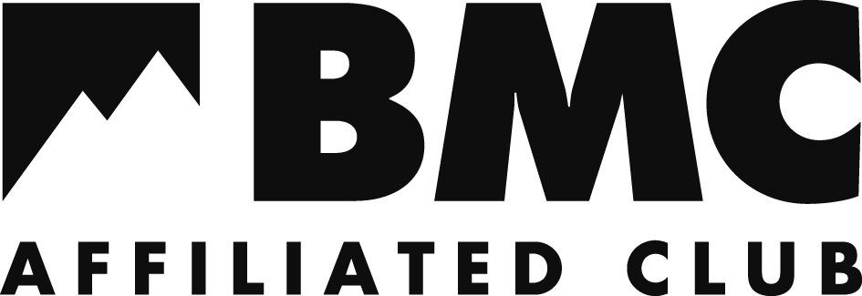
V.2019.01.08
Newbury Mountain Club - Membership Form

Please complete this form and return to ‘secretary@newburymountainclub.org.uk’ along with payment of £20 for annual membership. A notification of payment should be sent to ‘accounts@newburymountainclub.org.uk’.
NMC membership is only open to persons aged 18 and over (see club rules for guidance). All new, existing and prospective members must complete this form before attending an NMC trip. This ensures that their details are logged on the membership register so that they and NMC are covered by the BMC’s civil liability insurance policy. If a prospective member does not become a full member within 3 months of registering, their details will be removed from the membership register.

Part 1A – Membership Type
Membership Type: | Choose an item.

Part 2A – Personal Details
Title: | Choose an item. | First Name: | Click here to enter text. | Surname: | Click here to enter text.
Date of Birth (Day/Month/year) |  | Click here to enter text.
Address 1 |  | Click here to enter text.
Address 2 |  | Click here to enter text.
Town |  | Click here to enter text.
County |  | Click here to enter text.
Postcode |  | Click here to enter text.
Telephone |  | Click here to enter text.
E-mail |  | Click here to enter text.

Part 2B – Emergency Contact Information
Name | Click here to enter text. | Relationship | Choose an item.
Telephone | Click here to enter text. | E-mail | Click here to enter text.

Part 2C – Data Protection & Privacy
We take the privacy of our members’ data seriously and will only use your personal information for club administration purposes and for communicating with you about your membership. Only specified members of the committee will be able to access your details. More information about how we look after and use your data can be found at http://www.newburymountainclub.org.uk/privacy
As a BMC-affiliated club we will provide your name, contact details and date of birth to the BMC to administer your membership of the BMC including your combined liability insurance cover. The BMC will use your data to communicate with you about your membership. The BMC will contact you to invite you to create a ‘Member Profile’ which, amongst other things, allows you to set and amend your privacy settings. More information about how the BMC uses data can be found at www.thebmc.co.uk/privacy.
We will never share or sell your data without your prior permission.

Part 3 – Declaration
By signing this form you:
- Confirm that you are over 18 years of age.
- Acknowledge the NMC Constitution and Rules as detailed on the clubs website and agree to be bound by them.
- Acknowledge that climbing and mountaineering are activities with a danger of personal injury or even death and accept personal responsibility for these risks and for your own level of ability and experience. You agree to act responsibly at all times and with due care and attention to limit the risk of injury to yourself or any other person (whether an NMC member or not).
- Acknowledge that NMC is a group of individuals with common interests which does not provide qualified training or instruction, and agree that neither NMC nor any NMC member shall be liable for any loss or damage suffered by any person as a result of participation in NMC trips, activities or as a result of NMC equipment being loaned to you.
- Agree to maintain general good health and to inform the trip organiser and one other committee member if you have a medical condition or prior injury that may affect you taking part and satisfy yourself that any proposed activity or trip is within your capabilities.
- Agree to provide suitable and adequately maintained equipment for your own use as specified by the organiser of any NMC activity or trip or as may be reasonably necessary, and be solely responsible for any loss or damage to your property.

Signed | Insert scan of signature or print off form and sign below: | Date | Click here to enter a date.

